**Financial Dashboard for CRED Creation Using Power BI and Excel**

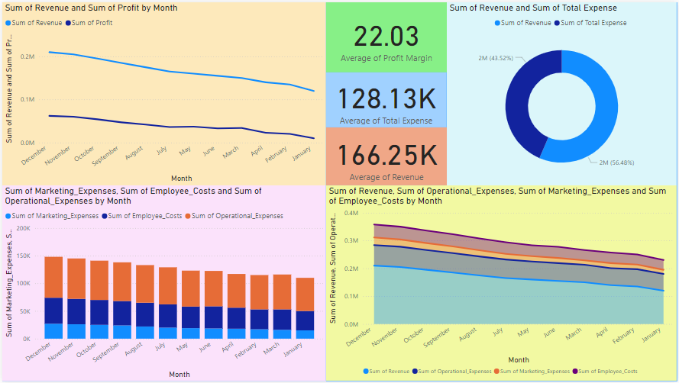

Based on Data of year 2023 related to revenue, operational and marketing expenses, employee cost and profits provided from your side we have created a Dashboard showing below parameters

1. Average of Revenue margin, Expense and Revenue   
   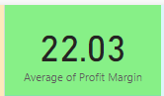
2. Average of Total Expense   
   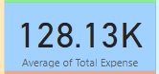
3. Average of Revenue   
   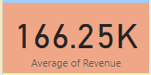
4. Line Chart of Monthly Revenue and Profit  
   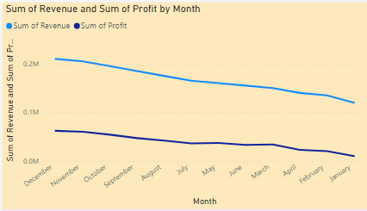
5. Donut chart of total revenue and total expense  
   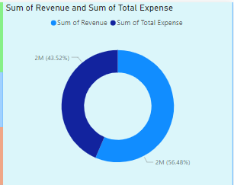
6. Stacked bar chart with details of monthly expenses  
   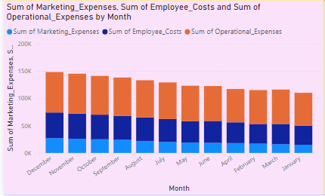
7. Stacked area chart with all details, revenue, operating expense, marketing expense and employee expense  
   